**Simplified Software Requirements Specification (SRS) for Vehicle Maintenance and Mileage Tracker**

**1. Scope**

The Vehicle Maintenance and Mileage Tracker (VMMT) is a comprehensive software application designed to empower individual car owners and small businesses managing fleets of vehicles. It offers robust capabilities for tracking and managing vehicle maintenance schedules and mileage. This system ensures real-time accuracy in monitoring mileage, fuel consumption, and maintenance schedules, while also delivering timely alerts for upcoming maintenance tasks and maintaining a complete history of all maintenance activities.

**2. General Description**

**a. Target audience**

The primary target audience for the VMMT encompasses individual car owners who seek to keep their vehicles in optimal condition and small businesses responsible for maintaining and managing a fleet of vehicles. The application's user-centric design caters to the unique needs of these user groups.

**b. Objectives**

The core objectives of the VMMT are as follows:

1. **Accurate Mileage and Fuel Tracking**

The system must provide precise tracking of vehicle mileage and fuel consumption, whether through manual input or automatic data retrieval via the OBD (On-Board Diagnostics) port. This ensures that users have access to up-to-date information regarding their vehicle's performance.

1. **Scheduled and Preventive Maintenance**

The VMMT aims to facilitate scheduled and preventive maintenance, thereby enhancing vehicle longevity. It assists users in planning maintenance tasks based on real-time data, reducing unexpected breakdowns, and saving on repair costs.

1. **Alerts and Notifications**

The system will deliver alerts and notifications to users, ensuring that they are informed of upcoming and overdue maintenance tasks. This feature enhances safety and reliability by preventing lapses in vehicle maintenance.

1. **Maintenance History**

The VMMT will maintain a comprehensive history of all maintenance activities, enabling users to track the service history of their vehicles. This historical data aids in making informed decisions about future maintenance and repairs.

**c. Constraints**

To ensure the integrity and security of the system, certain constraints must be adhered to:

* **Privacy and Data Protection Standards:** The VMMT will comply with established privacy and data protection standards, safeguarding user information and data.
* **Cross-Platform Development:** The application will be developed for both iOS and Android platforms, ensuring accessibility to a wide range of users.

**3. Functional Requirements**

1. **User Registration and Login:** Users must be able to register, create an account, and log in to the application.
2. **Vehicle Registration:**

* Users can add details of their vehicles, including make, model, year, and VIN (Vehicle Identification Number). This feature enables users to create profiles for their vehicles within the application.
* At any time, users should have the flexibility to edit the details of their registered vehicles. This ensures that the information remains accurate and up-to-date.
* Users may register multiple vehicles under a single account. This feature is particularly beneficial for small businesses managing fleets of vehicles.

1. **Mileage Tracking:**

* **Manual Mileage Entry:** The system allows users to manually log vehicle mileage. Users can enter mileage data when necessary, ensuring accurate tracking of their vehicles' distances traveled.
* **Automatic Mileage Tracking via OBD Port:** For enhanced convenience, users can opt for automatic mileage tracking through the OBD port. This feature retrieves real-time mileage data directly from the vehicle's onboard systems.
* **View Mileage Summaries:** Users can access summarized mileage information, available in daily, weekly, and monthly formats. These summaries provide valuable insights into the vehicle's usage patterns.

1. **Fuel Consumption Recording:**

* **Record Fuel Fill-up Details:** Users can record details of fuel fill-ups, including the number of gallons filled, the cost of fuel, and the miles driven since the last fill-up.
* **Calculate Miles per Gallon:** he system calculates and displays the miles per gallon (MPG) for each fuel fill-up. This metric assists users in evaluating their vehicle's fuel efficiency.
* **Generate Fuel Consumption Reports:** Users can generate detailed fuel consumption reports, offering insights into their vehicles' fuel efficiency and expenses over time.

1. **Maintenance Scheduling:**

* **Schedule Maintenance Tasks:** Users can schedule upcoming maintenance tasks, such as oil changes, tire rotations, or inspections. This feature helps users plan and manage their vehicle maintenance proactively.
* **Calculate Maintenance Mileage:** The system calculates the recommended maintenance schedule based on the vehicle's mileage. It ensures that maintenance tasks are performed at appropriate intervals.
* **Generate Maintenance Schedules:** Users can generate maintenance schedules, allowing them to view a list of upcoming and overdue maintenance tasks. This feature helps users stay on top of essential vehicle upkeep.

1. **Maintenance Logging:**

* **Log Completed Maintenance Tasks:** Users can log completed maintenance tasks, recording essential details such as the date of service, mileage at the time of maintenance, task details, and associated costs.
* **Confirmation of Completed Tasks:** Upon logging a completed maintenance task, users receive confirmation within the application. This acknowledgment provides peace of mind that the task has been successfully marked as complete.

1. **Alerts and Notifications:**

* **Receive Maintenance Alerts:** The system sends users alerts and notifications regarding upcoming maintenance tasks, ensuring that users are aware of essential service requirements.

1. **Reporting:**

* **Mileage Reports:** Users can generate mileage reports available in daily, weekly, and monthly formats. These reports offer a comprehensive view of their vehicle's usage patterns.
* **Fuel Efficiency and Cost Reports:** Detailed fuel efficiency and cost reports are available, providing users with insights into their vehicle's fuel consumption and associated expenses.
* **Maintenance History Reports:** Users can access maintenance history reports that summarize past maintenance activities. These reports are valuable for tracking the service history of their vehicles.
* **Export Reports:** For further analysis and record-keeping, users have the option to export reports in PDF or compatible formats.

**4. Non-Functional Requirements**

1. **Usability:** The application prioritizes usability by offering an intuitive user interface. Users should find it easy to navigate the application and access its features without significant learning curves.
2. **Performance:** The VMMT focuses on delivering real-time updates for mileage tracking. Users should experience minimal latency when interacting with the system.
3. **Security:** To protect user data and maintain privacy standards, the system employs robust security measures. Data encryption, secure authentication, and secure storage practices are implemented.
4. **Compatibility:** The application is designed to be compatible with both iOS and Android platforms, ensuring accessibility to a broad user base.
5. **Scalability:** The system is architected to handle a large number of users and vehicles. Scalability measures are in place to accommodate growing user bases and expanding fleets.

**5. Use Case Models**

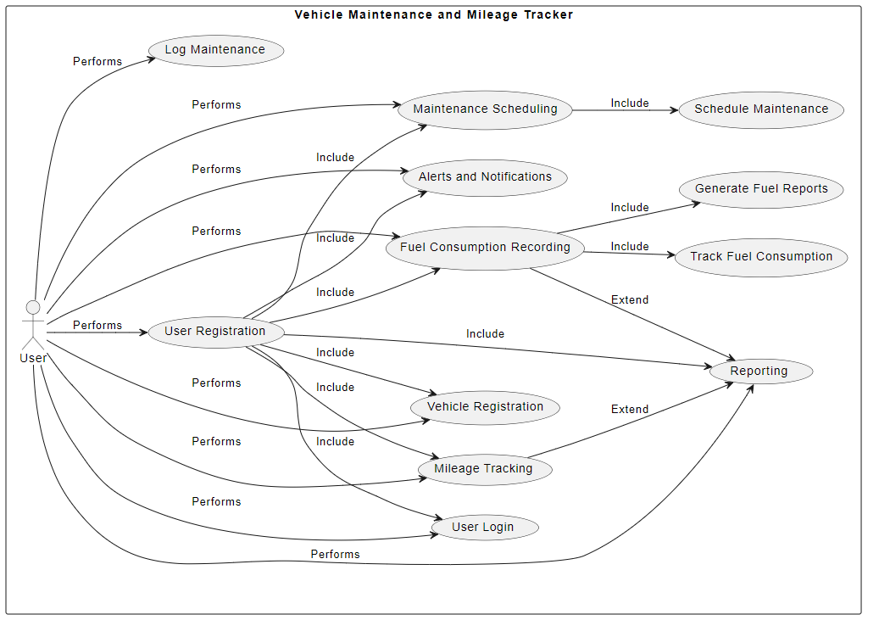

**6. Appendices**

**a. Definitions, acronyms, abbreviations**

* **VMMT**: Vehicle Maintenance and Mileage Tracker
* **VIN**: Vehicle Identification Number
* **SRS**: Software Requirements Specification
* **UML**: Unified Modeling Language

**b. References**

* IEEE Recommended Practice for Software Requirements Specifications. IEEE Std 830-1998.